Sharing from Tig

1. %SYSFUNC function.

%Sysfunc and %Syscall is a pair of very useful function, which can execute almost all SAS function based on open-code environment.
(Primary except function: symput, symget; execute, resolve; put, input)
1.1 %IF is not available in open-code. We can solve this problem by
%sysfunc(ifc(boolean, condition 1, condition 2<, missing condition>))

Example 1: (Notice: IFC can only consider two conditions and missing.)
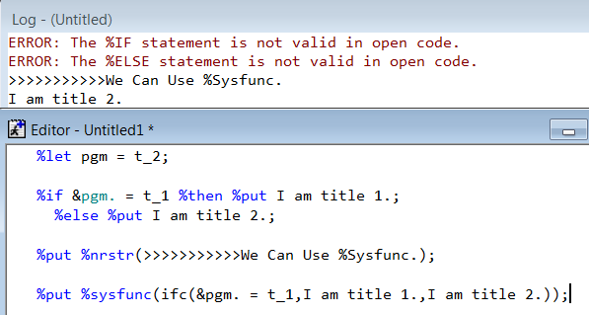

Example 2:
data one;
var1 = '1';
var2 = 2;
run;

%let var = var1;

%let rc = %sysfunc(open(one));
%let type = %sysfunc(vartype(&rc.,%sysfunc(varnum(&rc,&var.))));
%let rc = %sysfunc(close(&rc.));

data two;
set one;

new = %sysfunc(ifc(&type. = C,in,))put(&var.,best.);
run;

Example 3: (%nrstr: Use this function to avoid % and & compile and execute)
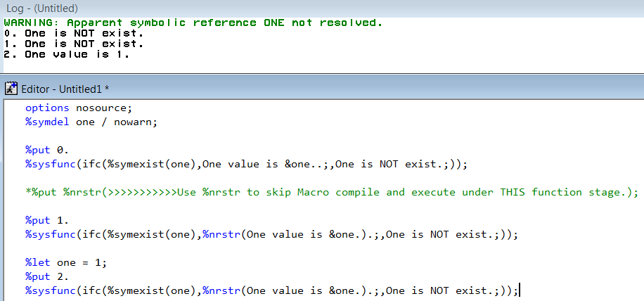

Is there a way to use SELECT function under open-code/Macro environment?

1.2 %SELECT is not exist in SAS. But we have another way to use it by
Format + %sysfunc(putn(Mvar, format)) [putn/c, inputn/c]

Example 4: We can write some value & function & statement into format.
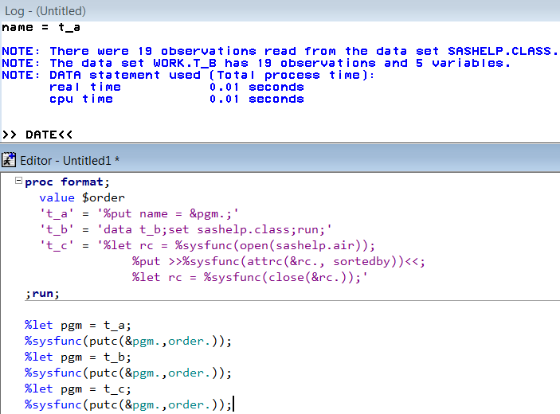
1.3 %IN is not exist in SAS. But we can use %sysfunc + whichc

Example 5: %Sysfunc with other useful function.
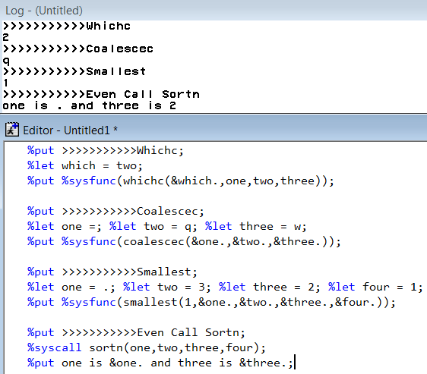
2 PRX group

PRX group function is useful to deal with Character String or Macro Text.
Almost all function can use by %Sysfunc and %Syscall except Pares, Match and Paren. But it’s not suggested to use by Call way because it may happen value truncation easily.

PrxPares:
Compile your ME(Metacharacter Expression) and return an integer id number if success. (Match and Change can omit this step and use expression in data step.)

PrxMatch:
Search for a pattern match and returns the position at which the pattern is found. (Like Index function.)

PrxPosn:
Return the value from a capture buffer. Need to use PrxMatch first.
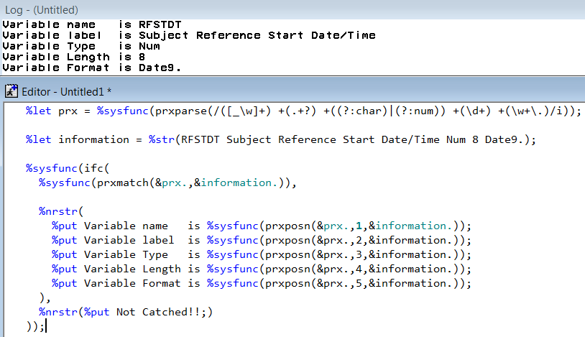
Notice: Using Call way may be returning the different result.
Call PrxPosn: Return the start position and length for a capture buffer.

PrxParen:
Return the last bracket match for which there is a match in a pattern.

PrxChange:
Perform a pattern-matching replacement.
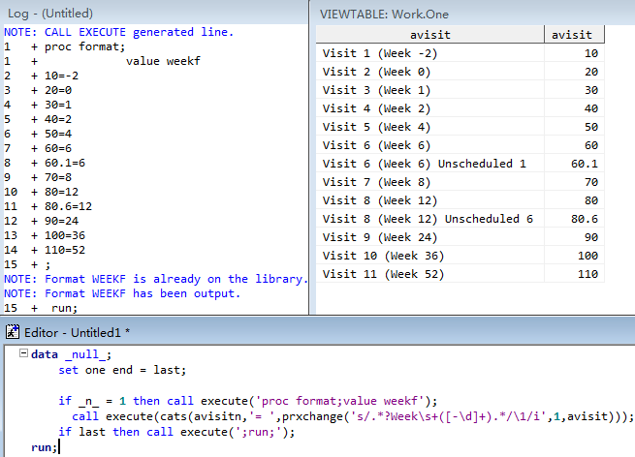

PrxSubstr:
Return the position and length of a substring that matches a pattern.

PrxNext:
Return the position and length of a substring that matches a pattern and iterates over multiple matches within one string.

Example 1: Use Do loop + PrxNext to add split mark into character string.
%macro cut(in=,out=&in.,var=,vout=&var.,len=,cut=);
%let vlen = %sysfunc(ifc(%length(%scan(&var.,2)),%scan(&var.,2),200));
%let var = %scan(&var.,1);

data &out.;
set &in.;

length prx_new $&vlen..;
retain prx_start prx_stop prx_pos 0 prx_len 1 prx_new;

prx_cut = prxparse('/.+[\s[:punct:]]/'); *PUNCT means all punctuation, \s means all white space.;
prx_start = 1;
prx_stop = &len.;
prx_new = '';

do until(prx_start ge length(&var.));
call prxnext(prx_cut,prx_start,prx_stop,&var.,prx_pos,prx_len);

if not prx_len then do;
put '>>>Length not enought for all obs, please re-assign.<<<';
put '>>>Overlength value is: ' &var. '<<<';
stop;
end;
prx_new = catx("&cut.",prx_new,substr(&var.,prx_pos,prx_len)); *Join disposed value onto new variable.;

prx_start = prx_pos + prx_len; *Refresh start position;
prx_stop = smallest(1,&vlen.,prx_start + &len.);
end;
&vout. = prx_new;

drop prx_:;
run;
%mend cut;

%cut(in=sashelp.vtable(keep = memlabel),out=vtable,var=memlabel,vout=new,len=25,cut=|);

Example 2: Use PrxNext + PrxParen to do some information collection.
When you want to format your dataset using the length & label extracted directly from the AD spec. You may meet some Error due to information out of date in spec and you are not convenience to update spec. So, maybe you need to UPDATE the information.
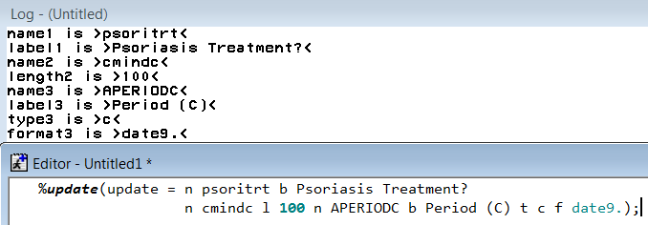
%let prx = %sysfunc(prxparse(/n +.*?(?=(?: n )|$)/));
%let prx1 = %sysfunc(prxparse(/(n +\w+)|(b +.+?(?=(?: n| t| l| f|$)))|
(t +(?:n|c|num|char))|(l +\d+)|(f +\w+\.)/));
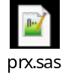

3. Data step
3.1 PDV(Program Data Vector), Compile and Execute and single / double quote.
PDV is a logical area in memory where SAS builds a data set, one observation at a time.

Processing order in a data step:
Macro function and Macro variable will compile and execute firstly. (Unless we use single quote to block it) After all active Macro symbol analysis over, data step read observation one by one, compile & execute.
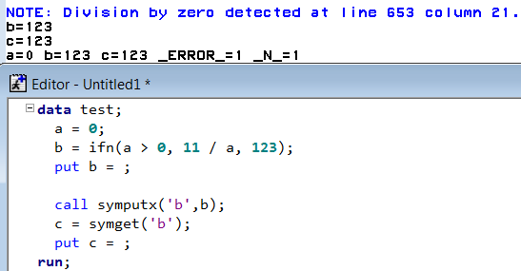

Using the “” or ‘’ instead of %bquote group function to mark the dangerous symbol, like un-paired punctuation, in Macro
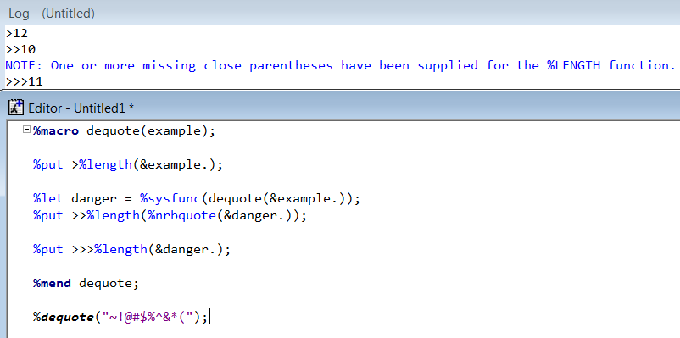

3.2 Set and Output.
Every data step will process all observation one by one during the observation loop. The looping times will decide by (input or set) * output when data step appear one of them. When several set statement use together, looping times will decided by the fewest observation by which dataset.
Notice: Array can do a crosswise looping for every observation looping. So, you want to use value from different variables, use Do over Array; you want to use value from different observation, just use PDV looping.
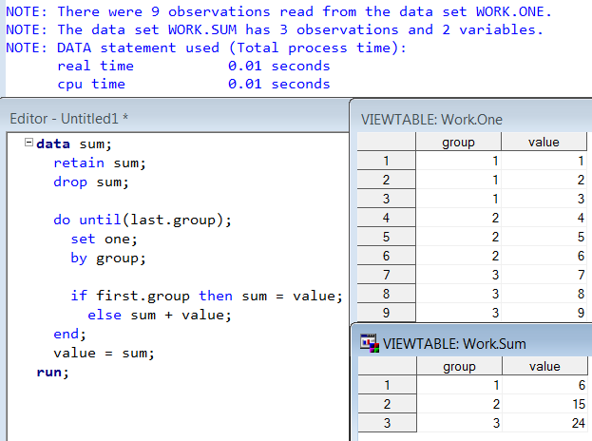
Set looping 9 times but execute only 3 times by DO until.

3.4 Some Useful Functions
3.4.1 Cat Group
My favorite feature for Cat group function is, strip(put(num, best.)) = cats(num)
And Cat function can be used to data step like Call execute, Prxparse, wherever character should be used.
Example: Use Catx function in Macro to dispose some condition.
%let by = usubjid paramn paramcd ;

%let by = %sysfunc(compbl(&by.));
%let comma = %sysfunc(tranwrd(&by.,%str( ),%bquote(, )));
%put Transform blank within words into comma, will be used in SQL;

%let quote = "%sysfunc(catx(%bquote(", "),&comma.))";
%put Use Catx function to add quote, will be used in HASH;

%let prx = %sysfunc(prxparse(s/(\w+)/key:\1/));
%let key = %sysfunc(prxchange(&prx.,-1.,%bquote(&comma.)));
%put Use Prx function to add some word, will be used in HASH;

%put _user_;

Log:
GLOBAL KEY key:usubjid, key:paramn, key:paramcd
GLOBAL QUOTE "usubjid", "paramn", "paramcd"
GLOBAL COMMA usubjid, paramn, paramcd
GLOBAL BY usubjid paramn paramcd
3.4.2 Intnx and Intck function
These two functions are very very useful on deal with Date calculate.
Example: Impute last day to a missing date.
data _null_;
noday = '2014-07';

impute = intnx('month',
input(cats(noday,'-01'),anydtdte21.),
0,'end');

totoday = intck('day',impute,input("&sysdate.",anydtdte21.));
put impute yymmdd10. @12 totoday;
run;

Log:
2014-07-31 113
3.4.3 Symput(x), Symget, Call Execute, Resolve
Symput and Symget function save and get macro variable value on data step execute.
Call Execute combine character information into command and execute when data step run over.
Resolve function resolve Macro Variable or Macro when data step execute, return result as a character string from Macro if produced.

4. Hash table
Hash table resolve insufficient for PDV’s look-back. It looks like a notepad that exchange message with PDV. So, in every PDV looping, you can consider all condition with other observation.

Use description:
1. You can load full main dataset into this notepad, and find/get value during PDV.
2. You can firstly declare an empty hash table, and save/modify value from PDV into this table.
3. You can do a hash table looping by declare a Hash Iterator Object.

Define a hash table:
Empty hash table: dcl hash h(<hashexp:??>);
With dataset: dcl hash h(dataset:’dsname’,<ordered:’ascending|a|yes|y’>);

Define key: h.definekey(‘usubjid’,’paramcd’); or h.definekey(all:’y’);
Define data: Same as define key: h.definedata(all:’y’);
Define finish action: h.definedone();

Key and Data:
Key is the most important thing in hash table, cannot be omit. Key’s task is to match with PDV’s variable value. Every group of keys associates with corresponding data.
Once key matched, we can choose update/get data to/from hash table. (Update to hash: add(), replace(); Get from hash: find())

Most useful functions:
Based on 9.1: Check & Find; Add, Remove & Replace; Output, NUM_ITEMS;
First & Last, Prev & Next.
Based on 9.2: Clear, Ref.

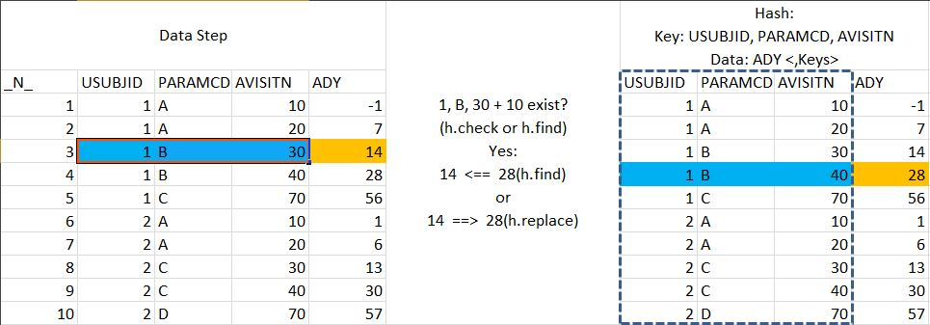

Example1: Easy example to do a SUM by group.
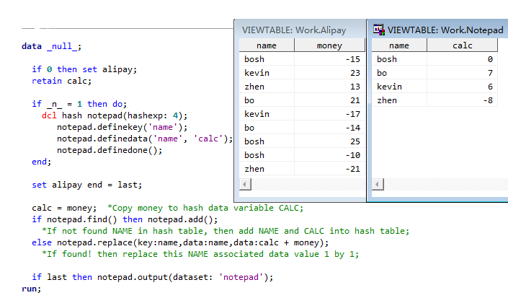
SQL maybe the best way to do a GROUP BY thing, data step + retain also is an effect way. When we met some problem, we should use most easy way resolve it, such as: Scan + Substr is better than Prx if worked.

Example2: Dummy.
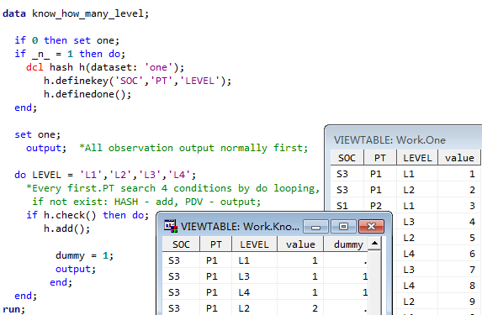

Another condition is not known how many levels’ logic which same as last example. (Code sees attachment.) Different is to build a small LEVEL hash table, and instead Do looping by Hash looping.
But we also have a more easy way to do the unknown level dummy:
proc transpose data = one out = t1;
by SOC PT;
id LEVEL;
var value;
run;

proc transpose data = t1 out = t2(rename = _NAME_ = LEVEL) prefix = value;
by SOC PT;
run;

Then, why I suggest using this method?
Because I personally think data step is one of the most flexible ways in SAS, and Hash table likes a mirror. Every observation looping, PDV can searching and do value interaction by all observation with itself/other table(s). It can help data step from two-dimension (Observations Loop + Variables Loop) increase to three-dimension.

Example3: Output N datasets by a variable’s value from original dataset.
*This example came from paper: Data Step Hash Objects as Programming Tools.
proc sort data = sashelp.class out = class;
by age;
run;

data empty;
if 0 then set class;
stop;
run;

data _null_ ;
dcl hash h(dataset: 'empty');
h.definekey(all:'y');
h.definedata(all:'y');
h.definedone();

do until(last.age);
set class;
by age;

h.add();
end;

h.output(dataset:cats('class_',age));
run;

Example4: Baseline Flag.
Baseline Flag Logic: For last record for each PARAMCD that is prior to RFSTDTC(VSDY le 1) then ABLFN = Y, null otherwise (Need to follow BR91).
data save test(drop = ablfl);set;run;

data test(drop = vsdy_hash);
if 0 then set test;
if _n_ = 1 then do;
dcl hash h(ordered:'y');
h.definekey('usubjid','vstestcd');
h.definedata('usubjid','vstestcd','vsdy_hash');
h.definedone();

do until(last);
set test end = last;
vsdy_hash = vsdy;
if 1 >= vsdy > . then do;
if h.find() then h.add();
else do;
vsdy_hash = max(vsdy, vsdy_hash);
h.replace();
end;
end;
end;
h.output(dataset:'base');
end;

set test;
vsdy_hash = vsdy;

if ~h.find() and vsdy_hash = vsdy and ~missing(vsdy) then ablfl = 'Y';
run;

proc compare base = save compare = test;
run;

Some time, we will face complex problem. I completely suggest separating it by several parts. So we can easily check every step if it achieve our expect effect.
But hash can really accommodate your logic, only if you can well-regulated carding your mind.

Example5: AVISITN rebuilt.
Description: This example from my project.
When a subject(per parameter) have two same AVISTN, we will about to rebuilt one of the AVISITN to the front or back AVISITN.
Rule about like this:
- When the front AVISITN not exists, reassign the min AVISITN to AVISITN – 10.
- When then back AVISITN not exists, reassign the max AVISITN to AVISITN + 10.
- When both front and back not exists, choose the max distance in ADY and TARGET DAY, and reassign the AVISITN accordingly.
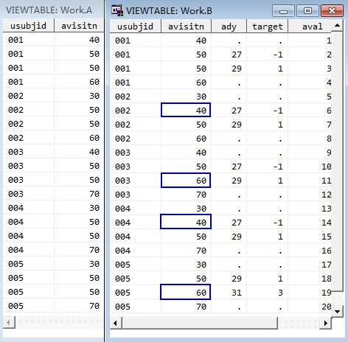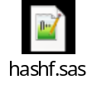

Other Un-coding share:
- Some Notepad ++ keys
- Ctrl + D and Tab, Bookmark and Two Comp View, Local and Ftp.
- Ctrl + points and Alt + lines
- Prx
- Notepad ++ Macro
Example: Align Operation.
Choose,Recording;
Cx,type: ~!@#$%^&*,Cn,Cv,Chome,Cright,CSleft,Cc,Ch
type: ^\s*(.*),Tab,Cv,type: \1,Tab,Sub,E,Point,Sub,A,Tab*2,E,Up,Esc
Ca,Cx,Cw,Cf,type: ~!@#$%^&*,Enter,Esc,Cv
Save;
Notice: This Macro needs you to place your file to LAST position.
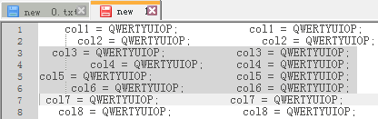
- Excel combine DV & QC
Use CONCATENATE function to merge a new column by DV and QC.
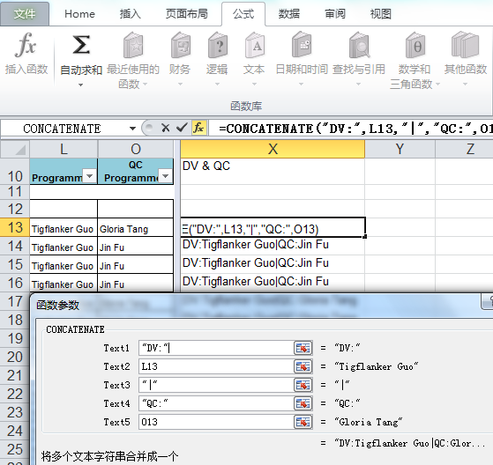
Then, Rebuilt the Filter.  - Unix forcedly kill a thread command is: kill -9 12345 | 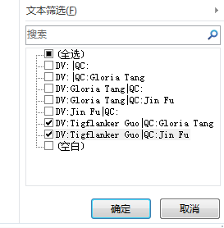
4. Many Points
4.1 To start an EXE when windows startup: pull the EXE’s shortcut into folder “C:\Users\guoti\AppData\Roaming\Microsoft\Windows\Start Menu\Programs\Startup”
4.2 To setup a command (like: alias sasm92='sas92 -rsasuser &') under UNIX, write it into .bashrc file.
4.3 Press Ctrl + Shift + Home/Up to select from cursor place to top.
4.4 Use %ABORT CANCEL; in your program to avoid wrong project.
%macro TIMSCHECK(TIMSCHECK);
%if &_TIMS. ne &TIMSCHECK. %then %do;
%ABORT CANCEL;
%end;
%mend TIMSCHECK;
%TIMSCHECK(211161);
proc datasets nolist lib=work memtype=data kill;quit;title;footnote;
… …

5. Three Software Share
5.1 Windows Hot Key (Green and Pass Company’s antivirus search)
5.2 Evernote (Green and Pass Company’s antivirus search)
5.3 DualMonitor (Pass Company’s antivirus search)
Download Place: /user1/guoti/Software

- My SAS keys share
DMKeys:
1. Start SAS with command: sas92 or sas93.
2. Send keys command in ToolBox.
3. Update and Save.
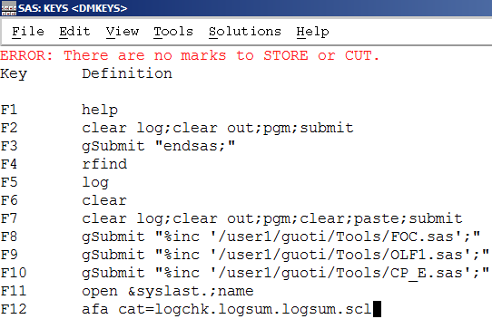

VTKeys:
1. Start SAS with command: sas92 or sas93.
2. Open a dataset.
3. Send keys command in ToolBox.
4. Update and Save.
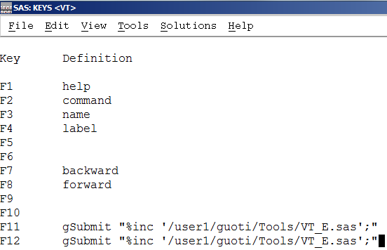

7. 人大经济论坛pobel版主系列：
7.1关于PDV的总结
Link: http://bbs.pinggu.org/thread-2337851-1-1.html

7.2关于Macro Variable
Link: http://bbs.pinggu.org/thread-2845461-1-1.html

7.3关于CALL EXECUTE()
Link: http://bbs.pinggu.org/thread-2377205-1-1.html

7.4关于Macro Quoting
Link: http://bbs.pinggu.org/thread-3111084-1-1.html

